*Make a career of humanity and you will make a greater person of yourself,*

*a greater nation of your country, and a finer world to live in.” – Dr. Martin Luther King, Jr.*

**Seal of Civics Readiness Community Service Project**

*“What we do for ourselves dies with us. What we do for others and the world remains and is immortal.”*

**What are Community Service Learning Activities?**

It’s the voluntary action of an individual or group of individuals without pay. Examples are: **conducting food drives**, **participating** in **adopt-a-highway programs**, **tutoring**, **teaching younger children**, **raking leaves** or **shoveling snow** for **elderly neighbors**. It’s an action in the community, involving community members where young people, adults and families come together to **work on a common interest or a need in the community**. Community-based service learning activities **meet genuine community needs** and require application of knowledge, skills and time to reflect. Volunteers need to be **actively engaged** designing projects that **address community needs**, **assessing community needs**, **reflecting** **before, during and after** their service experience.

**“Nothing’s stronger than the heart of a volunteer”**

**Overview: SO WHY VOLUNTEER??? Ultimately What is the Big Draw???**

Volunteering allows you to contribute to a cause relevant to your life.

You begin to see yourself as members of the community and take a step forward in learning about your responsibility to the world.

Volunteering allows you to succeed in an area different from academics, athletics or popularity.

Community service helps create sense of self-worth as you share your skills, talents and efforts.

You will develop a sense of being responsible for your community and a sense that citizenship requires you to actively participate in your community.

This is a way to build friendships so consider service projects that are done as a group.

Volunteering helps to boost self-esteem, especially when you receive positive reinforcement from the adults you work with. Be greedy. The praise is addictive. A lot of people love to volunteer because it actually makes them feel good helping others because of the praise they receive from others.

Starting no service increases the likelihood that you will develop a lifelong habit of service to others. You only have to do as little as ½ hour a week with your friends.

**Community Service Project Ideas**:

*The following is a list of ideas that I came up with to help if you need help getting started. Note these are only a list of suggestions of collecting or doing something for a particular type of organization in the area. If you decide to donate your time to a particular organization, contact the organization, do an activity make sure to discuss the project before you start.*

***Garage sale, Car wash, can & bottle deposits,*** *hold* ***raffle*** *items* ***donated from local business*** *and* ***raise money****to* ***donate cause****in community.*

*Organize* ***walking club, lead bingo game, entertainment variety show*** *for* ***nursing home senior citizens residents.*** ***Help*** *with* ***shopping, shoveling snow****.*

***Volunteer****as* ***museum guide****.*

*Become****library helper: Dress up*** *as* ***storyteller, plan*** *a* ***book-themed party****.*

*Start* ***after-school reading club****with younger****kids at local library****.*

*Work with* ***adult literacy program*** *to* ***teach reading.***

*Teach basic* ***electronics/computers*** *skills to****elderly****.*

***Tutor****someone* ***needs help learning English****.*

***Coordinate homework tutoring*** *for**youth who* ***need******schoolwork help.***

***Write booklet/information*** *about an issue concerned with and* ***ask the library to display it.***

***Help build Habitat for Humanity******home****.*

*Help****cook*** *and* ***serve meal at homeless shelter****. Volunteer for****Meals on Wheels****.*

*Organize* ***canned goods drive******food to food pantry/bank*** *with a* ***community event/school dance.***

*Make****first-aid kits for homeless****shelters.*

*Organize a****winter coat drive****.* ***Collect****and distribute donated****mittens, hats, scarves, socks****for people with limited resources.*

*Fill****laundry basket****with****household items****,****baby equipment*** *and* ***supplies****for****relocated migrant families****.*

***Collect, repair****and****donate used bikes****to local community agency.*

***Collect donations****of****old eyeglasses****to an organization that****recycles****them for people with limited resources.*

*Start program to****recycle athletic shoes.***

*Arrange of* ***donation drive working computers****get****donations from local business****for school.*

***Local parks and recreation department/community center.****Organize* ***family night****at center.* ***Community speakers****educate/promote awareness in community about* ***issue interested****in. Design/create* ***small discussion group teen****.*

***Volunteer*** *(Animal bathing, dog walking, facility clean up) at* ***local humane society/animal control****.****Fund-raise dog walk or pet wash day****.*

***Weed a public garden/ monument****.* ***Paint murals*** *over* ***graffiti****.*

*Ride* ***bike around****neighborhood****pick up trash.*** *Neighborhood day* ***pick-up trash in abandoned lot****. Set up* ***hazardous waste disposal day****. Organize* ***river cleanup****.*

*From government officials organize and****plant wildflowers/native plants in community garden****attract butterflies and honey bees. Set up****bird feeding stations/****bird houses.*

**PART 1: PLANNING Phase**. (3 hours)

**Pick a Community issue to focus on by determining needs of Community.**

**Brainstorm as a Group.** Discuss prominent issues or problems that need attention in your neighborhood and ways to address them. Prioritize your ideas selecting the best one. Think about what you would like to learn from the project.

**Select from the News.** Select stories that have emotional effects on your group. Discuss them together to select your project.

**Conduct a Survey.** Survey members of the community to find out about their greatest concerns. Do a project about which the community residents feel strongly. Perhaps community members will be inspired to help with your project.

**Research the Issues.** Do some web searches or go to the library and find out as much as you can about the problem in your community.

**Pick Focus for Project:**

**Objective:**  **Focus Topic of service project.**

**Problem Statement.** *Describe the problem in a single sentence, clearly and simply to focus on what you can do about it.*

**What I want I want to do in project:** *One or more sentences:*

**What** do you **want to do**?

**What** is **plan or goal**?

**What** do you **hope learn**?

**Why** is this service action **so important** for the community?

**Which** **specific groups** of people you think you will **help you make a change**?

*Example: Plan to organize club members in a mass planting of daffodil bulbs in various public locations in the city*. *Flowers will beautify the streets changing the thoughts people have about the community, which can reduce crime*.

**Goals**. Describe specific and practically, keeping the statements clear and simple. To know where you want to go and to determine how to get there.

**Activity Description**. *Describe activity clearly and simply in* ***2-3 sentences****.*

**What organized activities and actions** *can do* to help address the problem*?*

**How** will your **activity deal with the problem** and **address your goals**?

**What** you are **going to do**?

**How** you are **going to do it**?

**Why** are **going to do it**?

**Who** will you be **presenting your information to**, your **audience**?

**Specific objectives.**

**Through this project I want to meet plan to be met.**

Engage in the valuable work of helping others.

Practice life skills such as organizing, problem-solving and decision-making.

Increase communication skills.

Reinforce and further enhance skills and knowledge acquired.

Build teamwork, cooperation and diversity skills

Develop self-confidence and a sense of empowerment that comes from reaching out and helping others.

Practice good citizenship by making a difference in the community.

Gain experience in the work world.

Also, I would like to: (please list)

**PART 1: PLANNING** **Phase**.

**Action Plan.**

Help to get organized and to develop a time line once you have brainstormed what is needed to complete the project. Fill out an Action Plan table to help you get your project organized.

**Team Members**. Everyone must contribute to the project. (Think about members strengths and talents.)

*List the tasks. Who is responsible to complete them. What is needed. When the tasks need to be completed. What they have agreed to do. Refer back to the chart to monitor team members progress.*

**Who** are you **working with**, the names of **team members**?

***What*** *is* ***each person*** *is* ***responsible*** *for?*

*What* ***part*** *did they* ***agree to do****?*

***What’s needed*** *to* ***complete*** *their part?*

***When*** *will* ***tasks****need to be* ***complete*** *their* ***part****?*

***\*Note:*** *You can add rows.*

|  |  |  |  |
| --- | --- | --- | --- |
| **What are the tasks to be completed?** | **Who will do them?** | **What resources are needed?** | **When do they need to get done?** |
|  |  |  |  |
|  |  |  |  |
|  |  |  |  |
|  |  |  |  |

Studies show nine out of ten people say “yes” when someone asks them to donate their time.

**Ask yourself: What problems might I run into**?

**What Have I Forgotten?**

Leave enough time to gather necessary materials, to pick up last-minute supplies and to enjoy the energy that comes from doing these types of projects. There will always be **unexpected challenges** that come up on the day of the event, and a little humor in dealing with them helps the team members deal with the stress of the day.

**PART 2: RESEARCH** **Phase**. (3 hours)

*Identify a problem or issue you are passionate about, find out additional information.*

**Research Problem**: *Summarize research in four to five well-developed paragraphs.*

**Use library.** **Internet Research.** *Search relevant newspaper, magazine, reference articles find quotes and evidence.*

**Interview experts.** *Local government officials and non-profit organizations that work on the problem.*

**Survey community members**. *Ask questions people you know about the problem.*

**Summary.** **Write a 1-2 paragraphs for each** **focus** **research question.**

What causes the problem?

What’s the history of the problem?

What’s the problem’s impact and the effects on the community?

What’s the problem’s impact the effects on the country?

What’s the problem’s impact the effects on the world?

What do people affected by the problem want done

What are we going to do to address the problem?

**Contact Expert.**

*In field about project. Plan out how contact them, making sure email is professional.*

**Who are you contacting?**

Name:

Contact information:

Additional information:

Who are they?

What have they done?

Why are they important?

How can they help you?

What questions can you ask them?

**Email Requirements:**

**To: Salutation:** Professional and Respectful.

**Subject Line:** Appropriate.

**Body:**

**Introduce:** Yourself and goals.

**Purpose for writing them:** Questions to gain more information.

**Closing:** Thank them for their time.Ways they can contact you

**Signature:**

***Part 3: SERVICE Phase*. (10-12 hours)**

**Carrying It Out.**

This is the exciting part of the Community Service Project because you get to put your plan into action. Remember this is a team effort. Everyone in the group should know their responsibilities. Do your best and remember to have fun while helping out your community.

**Publicity.**

Good planning is crucial to any community service project. It’s what determines your project’s success. While developing your plan, consider your ultimate goals; Who will be helped by your service and if the project is needed. Use the information gathered, to plan the tasks, responsibilities, due dates and other “nuts and bolts” types of components in a community-based service learning project.

In addition to good planning, it’s important for you to inform the public of your planned community service learning project. Public awareness can contribute a great deal to your project’s success. You can help generate publicity by sending well-written news releases to local cable, radio stations and newspapers. Well-written news releases are concise, but still include “the 5 W’s and an H”: who, what, when, where, why and how.

**While doing the Service:**

**Save any products created.** *Research Notes, Contact Logs: Email and Phone Correspondence, Flyers, Information Booklets, Presentation materials, Announcements.*

**Get Quotes:** *From those who were your action community service aimed to help or from those you worked with, assisted your plan to be successful.*

**Take Pictures** **and Videos. Summarize**  *What occurred and what are the results of service?*

**Take lots of pictures** and enjoy the day, knowing that the team has planned for every possible challenge, and when the day is over, close it with some wrap-up questions.

**Reflect** *What worked and what didn’t?*

**Celebrate.**

Take time to celebrate the completed community service project. Be sure to find a way to let those key volunteers and funders who made the program successful feel appreciated. Provide refreshments, write a thank-you letter or pass out mementos of the day. “Goody bags” full of small candies with an attached thank-you note from you can be an inexpensive and tasty way to show appreciation.

**My community service project celebration included the following people or groups:**

**What we did to celebrate was:**

**Fill Out for EACH ACTIVITY.****Service Verification Form.**

*At every phase of the project (planning, research, service, presentation)*

***Throughout project:*** *Take detailed notes for reflection piece of project.*

*Answer reflection questions to explain and make connections.*

*Use complete sentences.* **Minimum 1-2 paragraphs.**

**Name:**

**Community Issue Addressed**   
*What was problem or issue saw in community?*  
*Why does problem exist?*   
*Why is there a need for the service?*  
*What was your plan to help community and how did you carry out plan?*  
**Brief Description of Learning & Planning:**

*Date(s) of Activity/Work***Name of Group, Organization or Agency:**

**Brief Description Community Service Activity:**  
Date(s) of Activity/Work   
*Total Number Service Hours:*

*Dear Supervisor:*  
*Name Group, Organization or Agency****:***  *When participation end of service project concluded, complete following:****I certify that student named has completed all hours documented.******Supervisor Name*** *(Typed/Printed)****Supervisor Signature*** *(Sign):****Phone*** *&/or* ***Email:***  *Date:*

***Part 4: PLANNING PRESENTATION Phase*. (6 hours)**

**Outline.** How share what learned.

**Title.** Names of group members.

**Quick Introduction.**

Why did you choose the topic?

What does the topic mean to you?

What is your solution to the topic?

**Topic Problem and Solutions**. *Detailed including visuals that illustrate.*

**Stakeholders.**

Who are involved with the issue? How are they Impacted?

**Steps took to learn about issue.** *Research findings that led to the project.*

What previous actions have been taken?

Were they successful?

What problems arose during completion of project?

Any difficulties you encountered completing project.

How did you overcome them?

How did you deal with or work around those issues?

**Celebration.** *Identify key volunteers.*

What did you do to celebrate them?

**Solution.** Detail your objective and actions, service activity that took place.

**Action** and **Outcome.**

How was it implemented.

Was it successful?

**Reflection.**

What did your group learn while completing this project?

What have you learned about how the "system" works?

What skills, knowledge or understandings could you take with you to college or into your life as an engaged citizen?

What might you have done differently if you were to start this project over?

Overall, how satisfied are you with the outcome of your project?

**Questions from Committee members.** *Be prepared to take specific questions.*

**PLANNING PRESENTATION Phase. Checklist.**

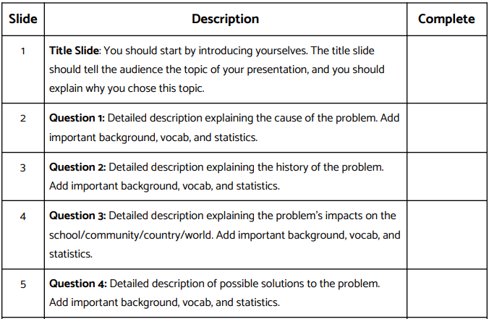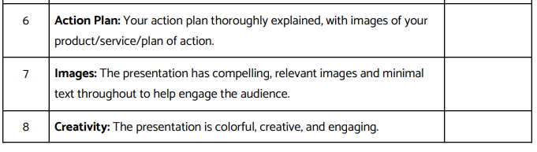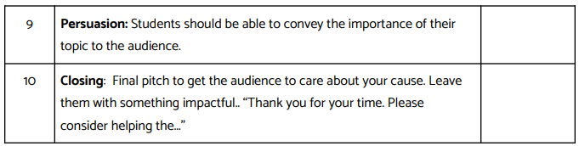

***Part 5:* PRESENTATION Phase. Rubric. *(8-10 minutes)***

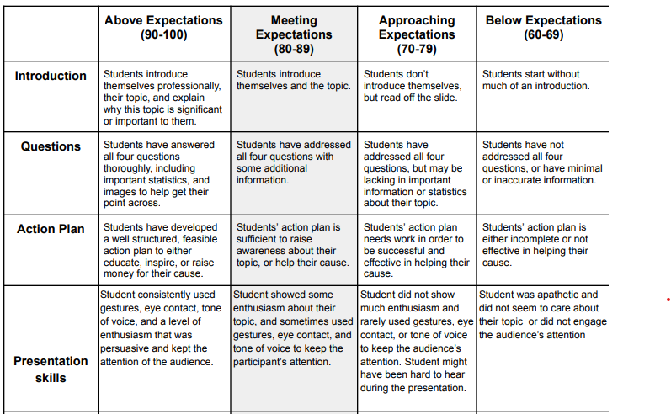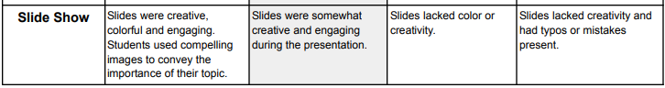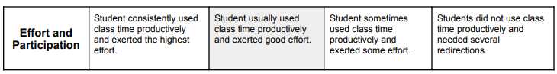

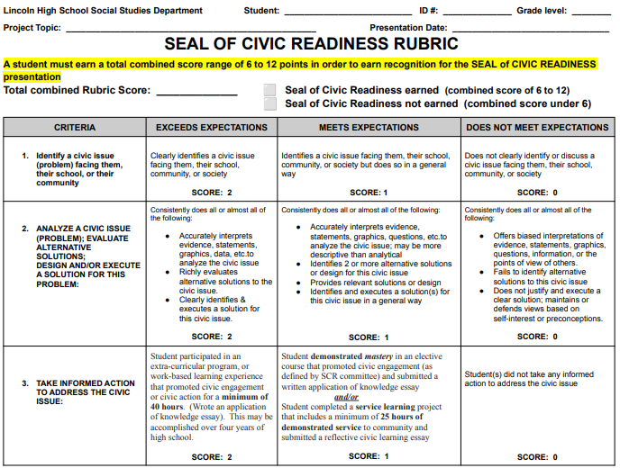

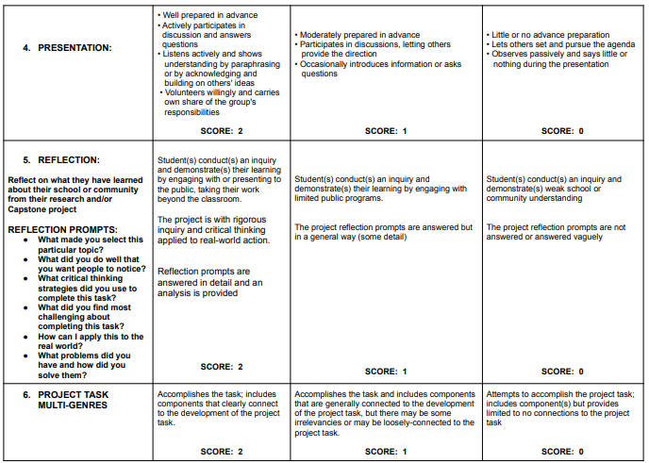

***Part 6:* Reflection. Discovering What Was Learned.**

**Write-Up*.*** *(1-2 pages)*

Service Project **Experiences** and **Results**. *What you did? What you learned?*

As a result of your project, many of you should experience and learn new things. It is important that you take the time to share your thoughts and feelings with one another. This process is known as reflection. Take the time out at the conclusion of your project for discussion. Bring up both positives and negatives. Be sure throughout the entire project to have someone taking notes. These tips will be helpful next time you decide to take on a problem-solving task.

Also consider including those that received the results of your service project to reflect on the experience. This doesn’t happen in many situations and can be a wonderful learning tool for you as well.

There are many ways for you display your reflection process these include after you participate in a group discussion, write in a journal and create a web page. I would build the web page before, during and at the end of the project making it public at the end once my reflection piece is completed.

**Reflection should Include:**

**Looking back at the overall service experience.**

This is what I did:

This is what I learned:

I helped:

I think that the project made a difference because:

My thoughts and feelings as I did the project were:

Next time I would:

As I look back at the objectives that chose, those that I accomplished were:

I can apply the skills that I learned from the project in this way:

Overall, feeling about that the project:

**Sharing:**

What actually happened during the community service events both positive interactions and learning experiences.

I helped:

I think that project made a difference because:

**Processing:**

What learned?

What was important, make sure to include problems and issues occurred.

How did you feel about the experiences?

Next time I would:

**Generalizing:**

What life skills learned during experience.

Thoughts and feelings while doing project:

Looking back at objectives chosen what did I accomplished:

**Applying:**

What learned to other experiences, reflect on learning.

Think about how can use the life skills and knowledge learned to other situations in your life, classroom, job, with friends, family and community.

Apply skills learned from project by:

Overall, feeling about project:

